

National Textile University
Department of Computer Science
Subject:
Mobile App Development

Submitted to:
Sir Rehan Sarwar

Submitted by:
Ahsan Maqsood

Reg number:
1130

Lab no. :
04

Semester:

6th

Task 1 –
import 'package:flutter/material.dart';

void main() {
runApp(const HomePage());
}

class HomePage extends StatelessWidget {
const HomePage({super.key});

@override
Widget build(BuildContext context) {
return const MaterialApp(
home: Scaffold(
body: SafeArea(
child: Column(
mainAxisAlignment: MainAxisAlignment.center,
children: [
CircleAvatar(
radius: 60,
backgroundColor: Colors.blue,
child: Icon(
Icons.person,
size: 60,
color: Colors.white,
),
),
SizedBox(height: 16),
Text(
'Ahsan Ali',
style: TextStyle(
fontSize: 24,
fontWeight: FontWeight.bold,
),
),
],
),
),
),
);
}
}
OUTPUT:
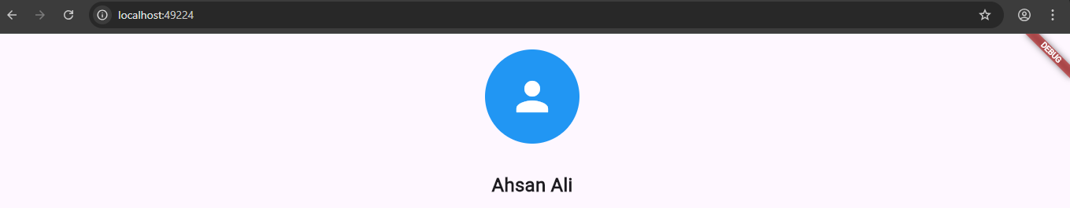

TASK 2:
import 'package:flutter/material.dart';

void main() {
runApp(const HomePage());
}

class HomePage extends StatefulWidget {
const HomePage({super.key});

@override
State<HomePage> createState() => _HomePageState();
}

class _HomePageState extends State<HomePage> {
bool isFollowed = false;
int score = 0;

@override
Widget build(BuildContext context) {
return MaterialApp(
home: Scaffold(
body: SafeArea(
child: Column(
mainAxisAlignment: MainAxisAlignment.center,
children: [
const CircleAvatar(
radius: 60,
backgroundColor: Colors.blue,
child: Icon(
Icons.person,
size: 60,
color: Colors.white,
),
),
const SizedBox(height: 16),
const Text(
'Ahsan Ali',
style: TextStyle(
fontSize: 24,
fontWeight: FontWeight.bold,
),
),
const SizedBox(height: 10),
Row(
mainAxisAlignment: MainAxisAlignment.center,
children: [
ElevatedButton(
onPressed: () {
setState(() {
isFollowed = !isFollowed;
});
},
style: ElevatedButton.styleFrom(
backgroundColor:
isFollowed ? Colors.grey : Colors.blue,
),
child: Text(isFollowed ? "Following" : "Follow"),
),
const SizedBox(width: 10),
IconButton(
onPressed: () {
setState(() {
score++;
});
},
icon: const Icon(Icons.favorite_border),
color: Colors.red,
)
],
)
],
),
),
),
);
}
}

OUTPUT:
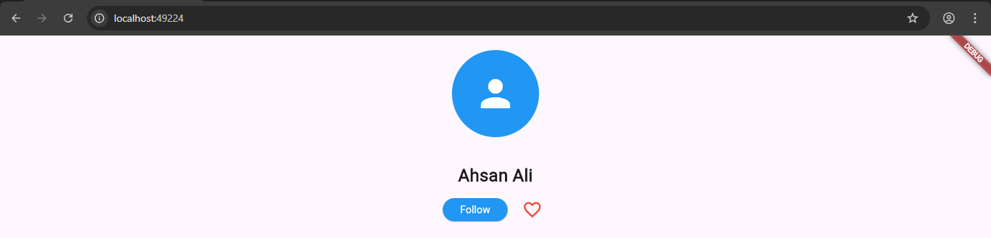

TASK 3:
import 'package:flutter/material.dart';

void main() {
runApp( (homepage()));
}
class homepage extends StatefulWidget {
const homepage({super.key});

@override
State<homepage> createState() => _homepageState();
}

class _homepageState extends State<homepage> {
bool isFollowed = false;
int score = 0;

@override
Widget build(BuildContext context) {
return MaterialApp(
home: Scaffold(
body: SafeArea(
child: Column(
crossAxisAlignment: CrossAxisAlignment.center,
children: [
Container(
margin: const EdgeInsets.all(20.0),
child: const CircleAvatar(
radius: 60,
backgroundColor: Colors.blue,
child: Icon(
Icons.person,
size: 60,
color: Colors.white,
),
),
),
const SizedBox(height: 16.0),
const Text(
'Ahsan Ali',
style: TextStyle(
fontSize: 24,
fontWeight: FontWeight.bold,
),
),
const SizedBox(height: 8.0),

Row(
mainAxisAlignment: MainAxisAlignment.center,
children: [
ElevatedButton(
onPressed: () {
setState(() {
isFollowed = !isFollowed;
});
},
style: ElevatedButton.styleFrom(
backgroundColor: isFollowed ? Colors.grey : Colors.blue,
),
child: Text(
isFollowed ? 'Following' : 'Follow',
style: const TextStyle(color: Colors.white),
),
),
const SizedBox(width: 12.0),
IconButton(
icon: const Icon(Icons.favorite_border),
onPressed: () {
setState(() {
score++;
});
},
iconSize: 28,
color: Colors.red,
),
],
),
const SizedBox(height: 24.0),
Card(
elevation: 4.0,
margin: const EdgeInsets.symmetric(horizontal: 16.0),
child: ListTile(
leading: const Icon(Icons.star, color: Colors.amber, size: 32),
title: const Text(
'Likes',
style: TextStyle(
fontSize: 18,
fontWeight: FontWeight.bold,
),
),
subtitle: Text(
'$score likes',
style: const TextStyle(fontSize: 14, color: Colors.grey),
),
trailing: Text(
'$score',
style: const TextStyle(
fontSize: 24,
fontWeight: FontWeight.bold,
color: Colors.blue,
),
),
),
),
],
),
),
),
);
}
}

OUTPUT:
